**Pre-Lab 7:**

**Characterization and DC Biasing of the BJT**

Name: Wan-Yu Liao

ECEN 325 Section 514

TA: Mandela

Date: October 18, 2019

**Calculations**

**(1)**

**NPN Resistive DC Biasing Circuit**

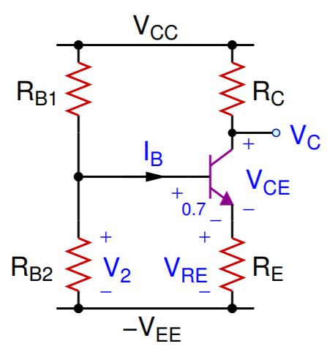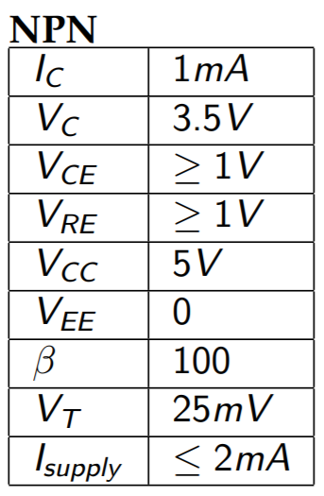



**PNP Resistive DC Biasing Circuit**

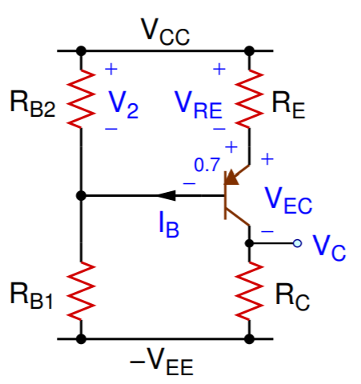 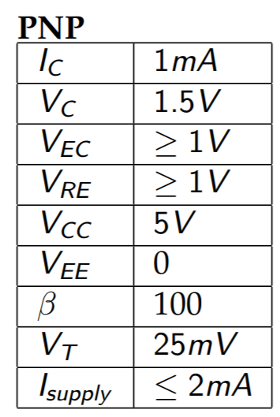



**(2)**

**NPN DC Biasing Circuit**

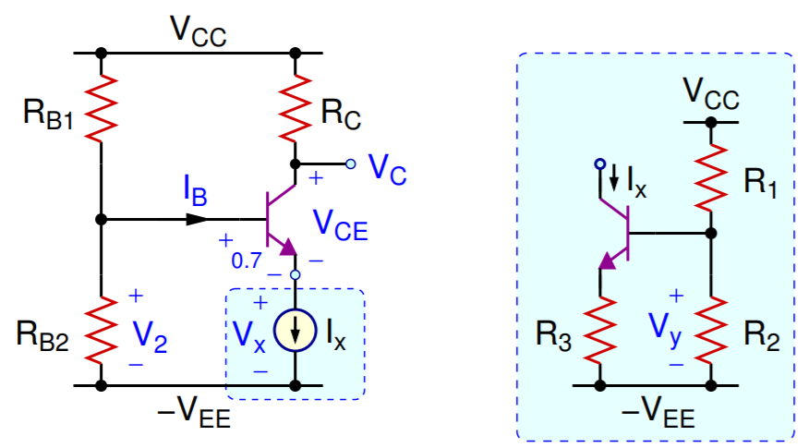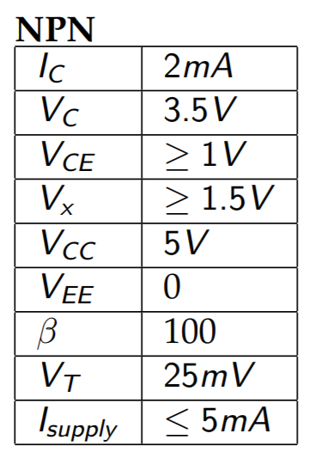



**PNP DC Biasing Circuit**

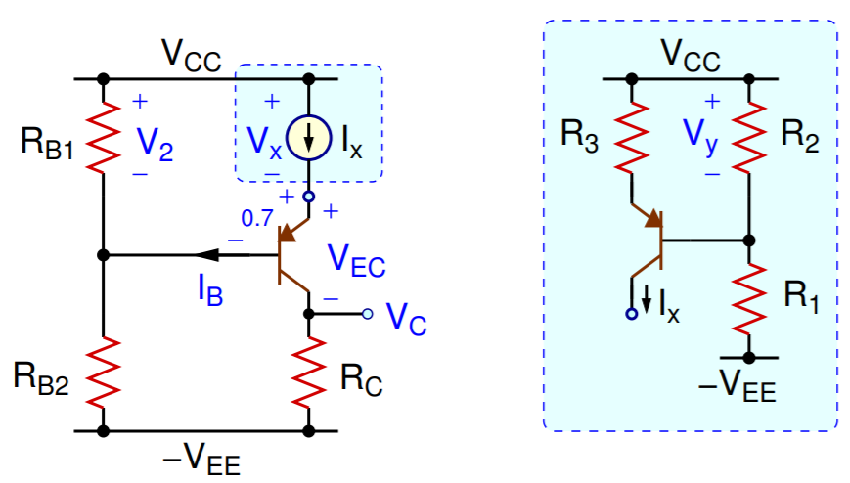 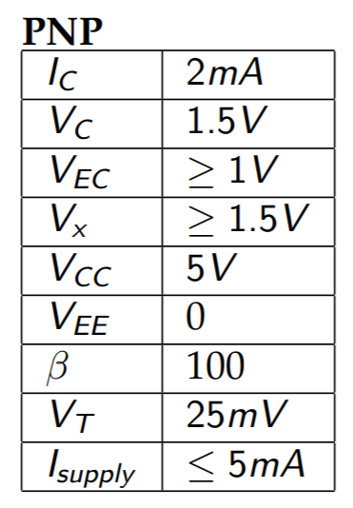



**Simulations**

**(1)**

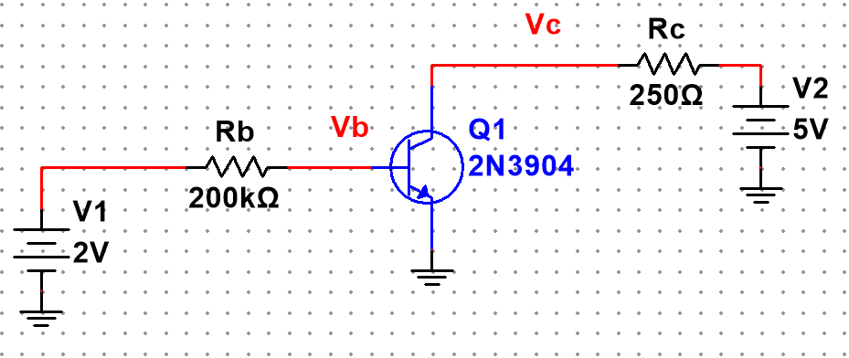

Figure 1: Schematic of NPN BJT characterization circuit for Fig. 2 ▲

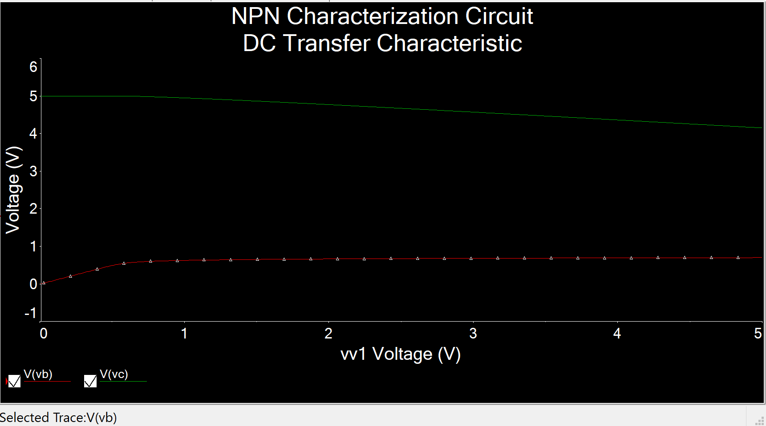

Figure 2: Simulation plot of NPN BJT characterization circuit using DC sweep of V1 from 0 to 5V, while V2 = 5V ▲

Figure 3: Excel plot for collector current (IC) of an NPN BJT as a function of Vbe ▲

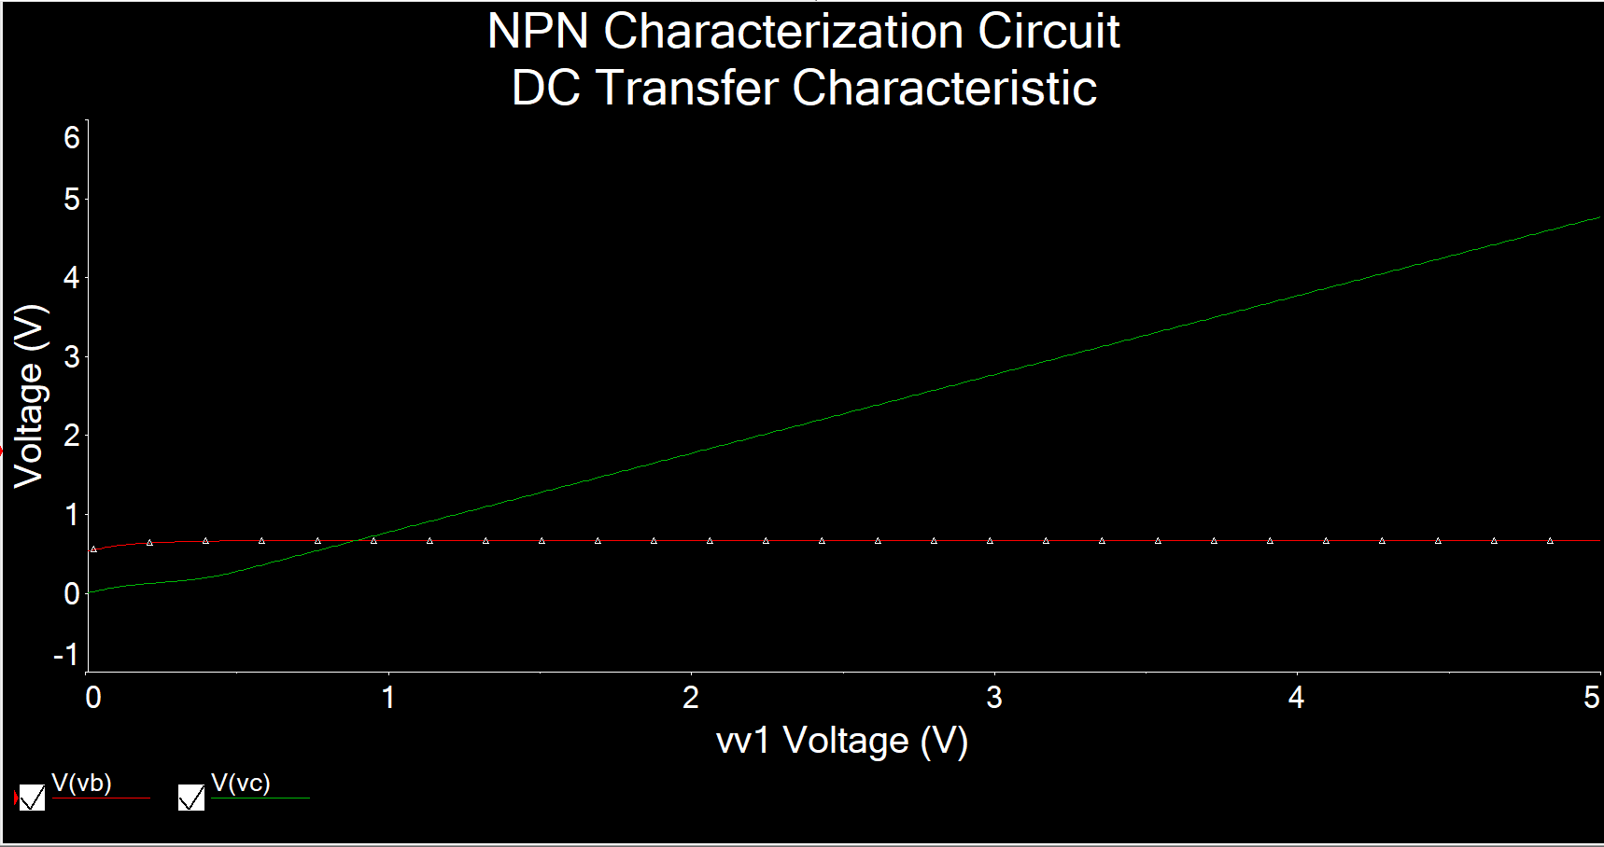

Figure 4: Simulation plot of NPN BJT characterization circuit using DC sweep of V2 from 0 to 5V, while V1 = 2V ▲

Figure 5: Excel plot for collector current (IC) of an NPN BJT as a function of Vce ▲

**(2)**

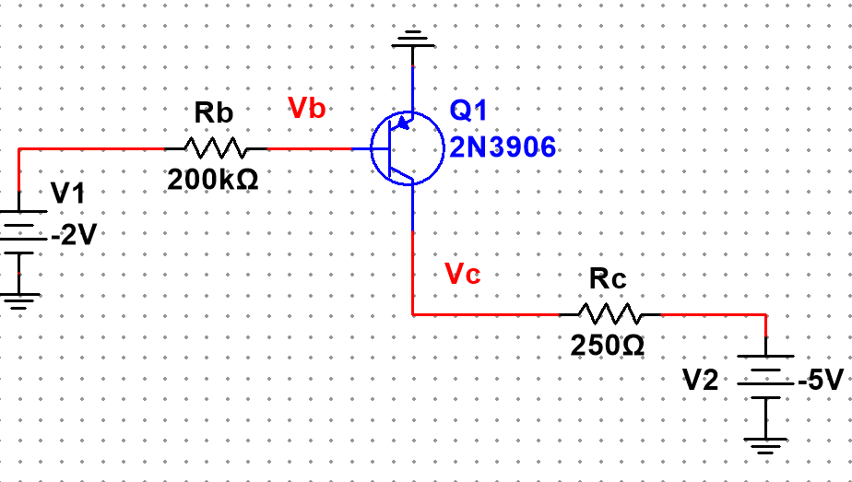

Figure 6: Schematic of NPN BJT characterization circuit for Fig. 4 ▲

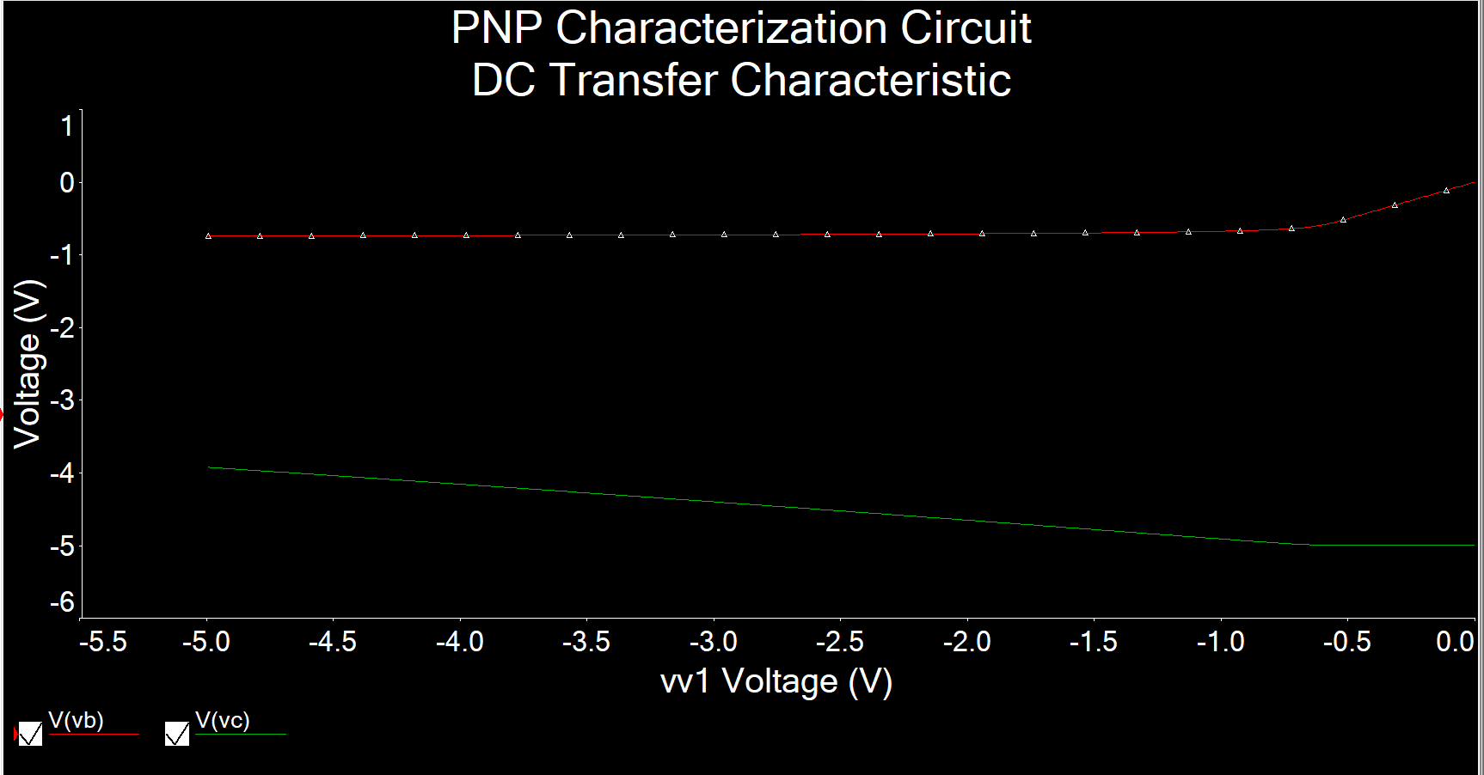

Figure 7: Simulation plot of PNP BJT characterization circuit using DC sweep of V1 from -5 to 0V, while V2 = -5V ▲

Figure 8: Excel plot for collector current (IC) of an PNP BJT as a function of Veb ▲

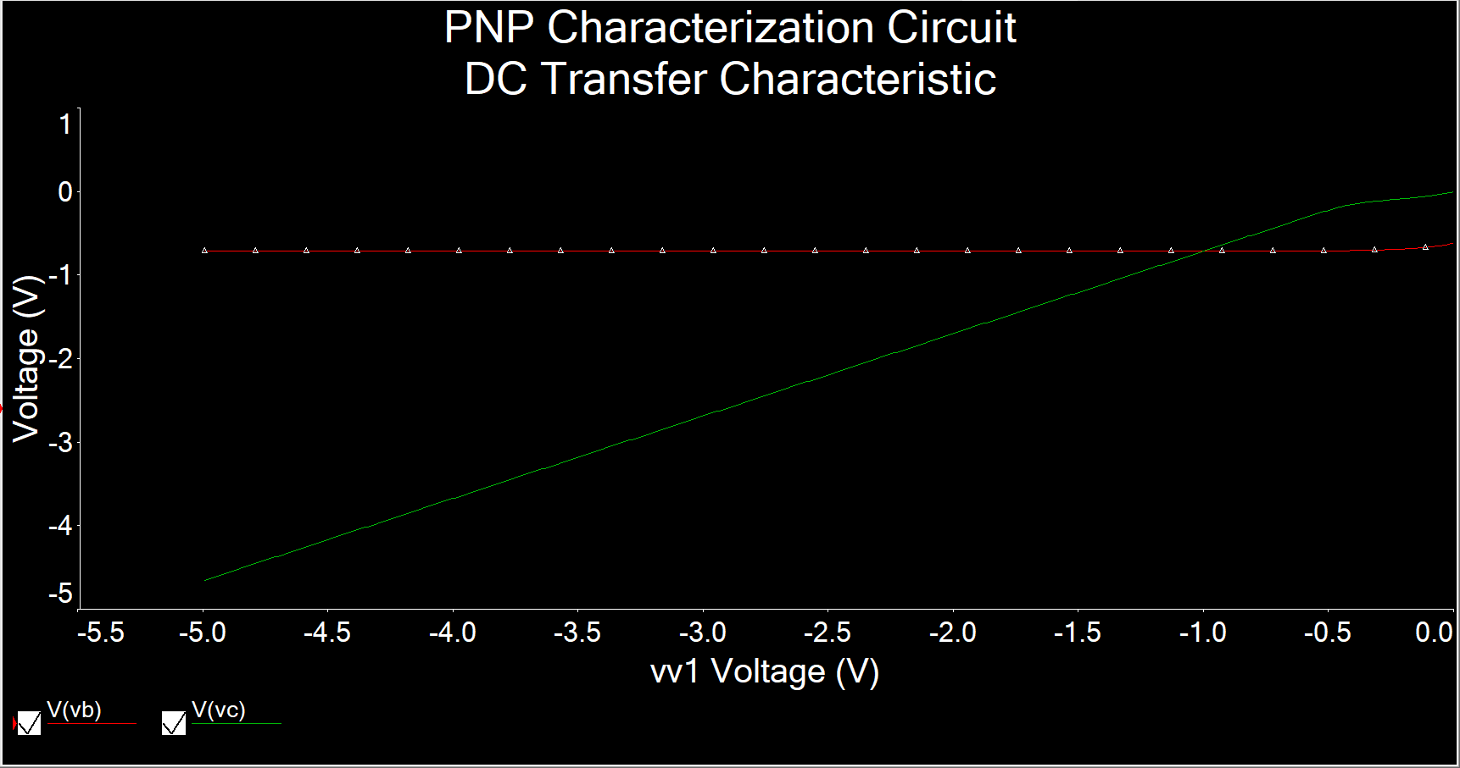

Figure 9: Simulation plot of PNP BJT characterization circuit using DC sweep of V2 from -5 to 0V, while V1 = -2V ▲

Figure 10: Excel plot for collector current (IC) of an PNP BJT as a function of Vec ▲

**(3)**

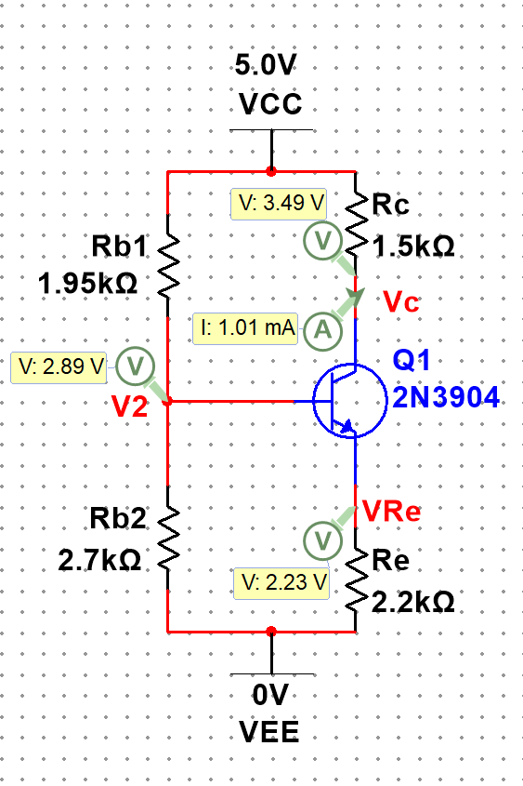

Figure 11: Schematic and interactive simulation for IC, VC, VRE, and V2 for NPN Resistive DC biasing circuit in Fig. 6(a) ▲

IC = 1.01 mA, VC = 3.49 V, VRE = 2.23 V, V2 = 2.89 V

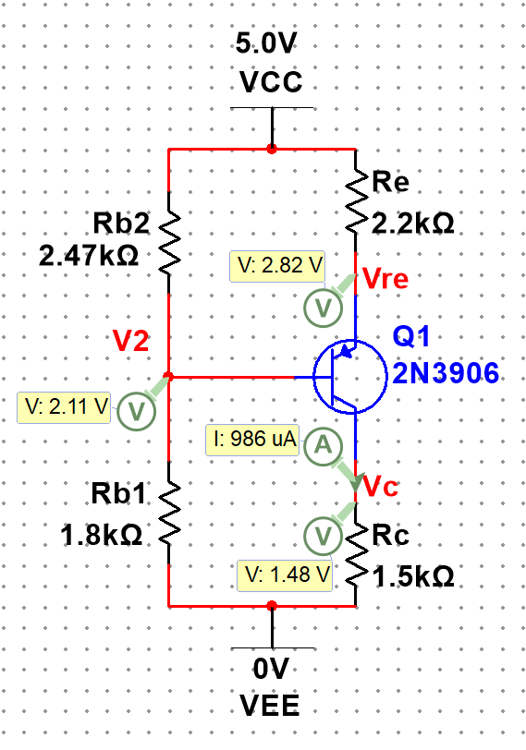

Figure 12: Schematic and interactive simulation for IC, VC, VRE, and V2 for PNP Resistive DC biasing circuit in Fig. 6(b) ▲

IC = 0.986 mA, VC = 1.48 V, VRE = 2.82 V, V2 = 2.11 V

**(4)**

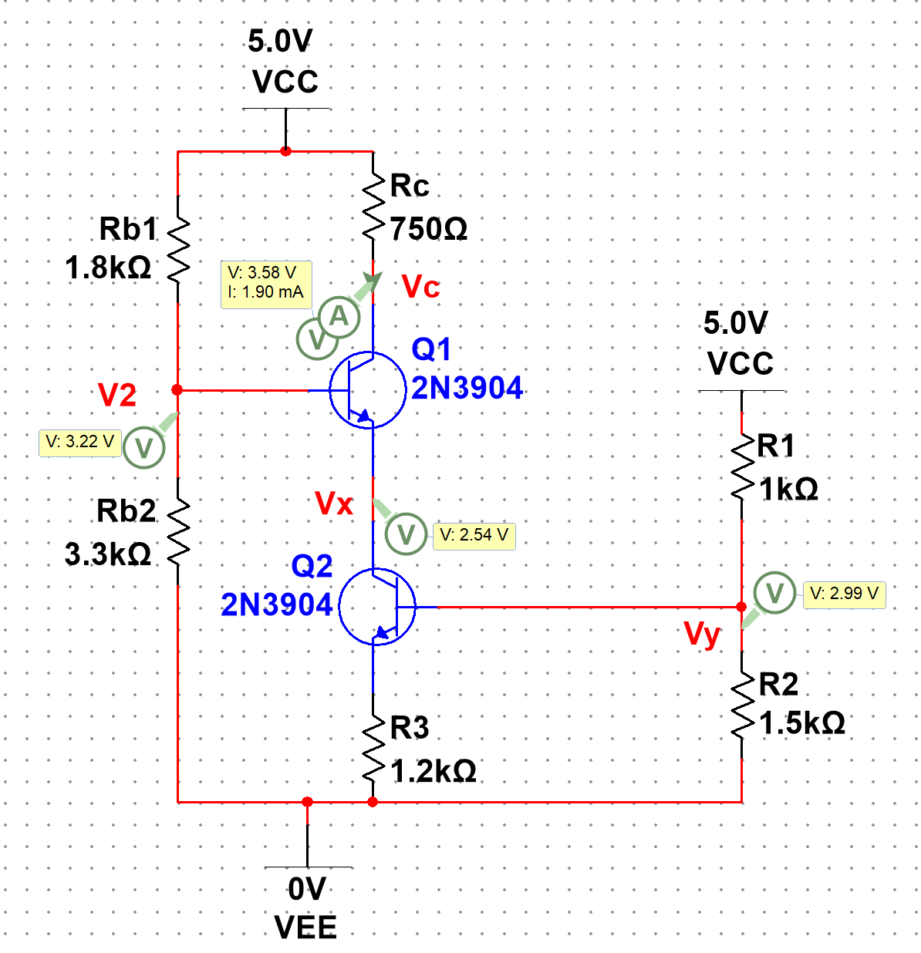

Figure 13: Schematic and interactive simulation for IC, VC, V2, Vx, and Vy for NPN DC biasing circuit using current source in Fig. 7(a) and Fig. 7(b) ▲

IC = 1.90 mA, VC = 3.58 V, V2 = 3.22 V, Vx = 2.54 V, Vy = 2.99 V

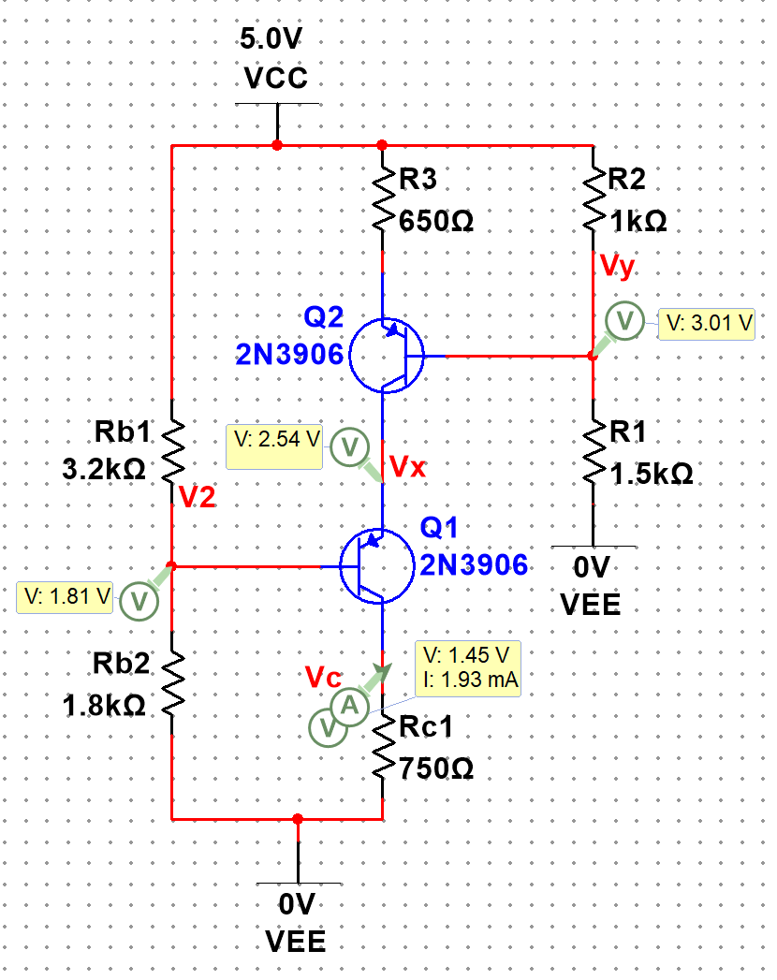

Figure 14: Schematic and interactive simulation for IC, VC, V2, Vx, and Vy for NPN DC biasing circuit using current source in Fig. 8(a) and Fig. 8(b) ▲

IC = 1.93 mA, VC = 1.45 V, V2 = 3.19 V, Vx = 2.54 V, Vy = 1.99 V